Public transportation optimization

# How is IoT used in public transportation?

Real-Time Vehicle Tracking

Luckily, the Internet of Things technology allows districts to easily track the location of their vehicles. Districts can install GPS systems on their vehicles that are connected to the internet. The GPS data is transmitted back to a central command center.

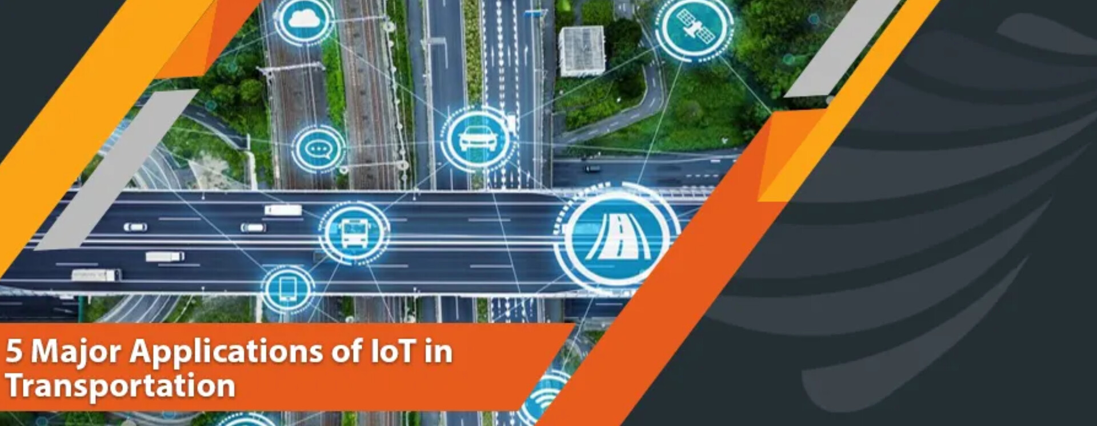Advanced Vehicle Tracking or Transportation Monitoring

Apart from location monitoring, IoT devices can also monitor the driver’s behavior and can inform about the driving style and idling time. In fleet management systems, IoT has minimized the operating and fuel expenditures along with the cost of maintenance.

What is the future of IoT in transportation?

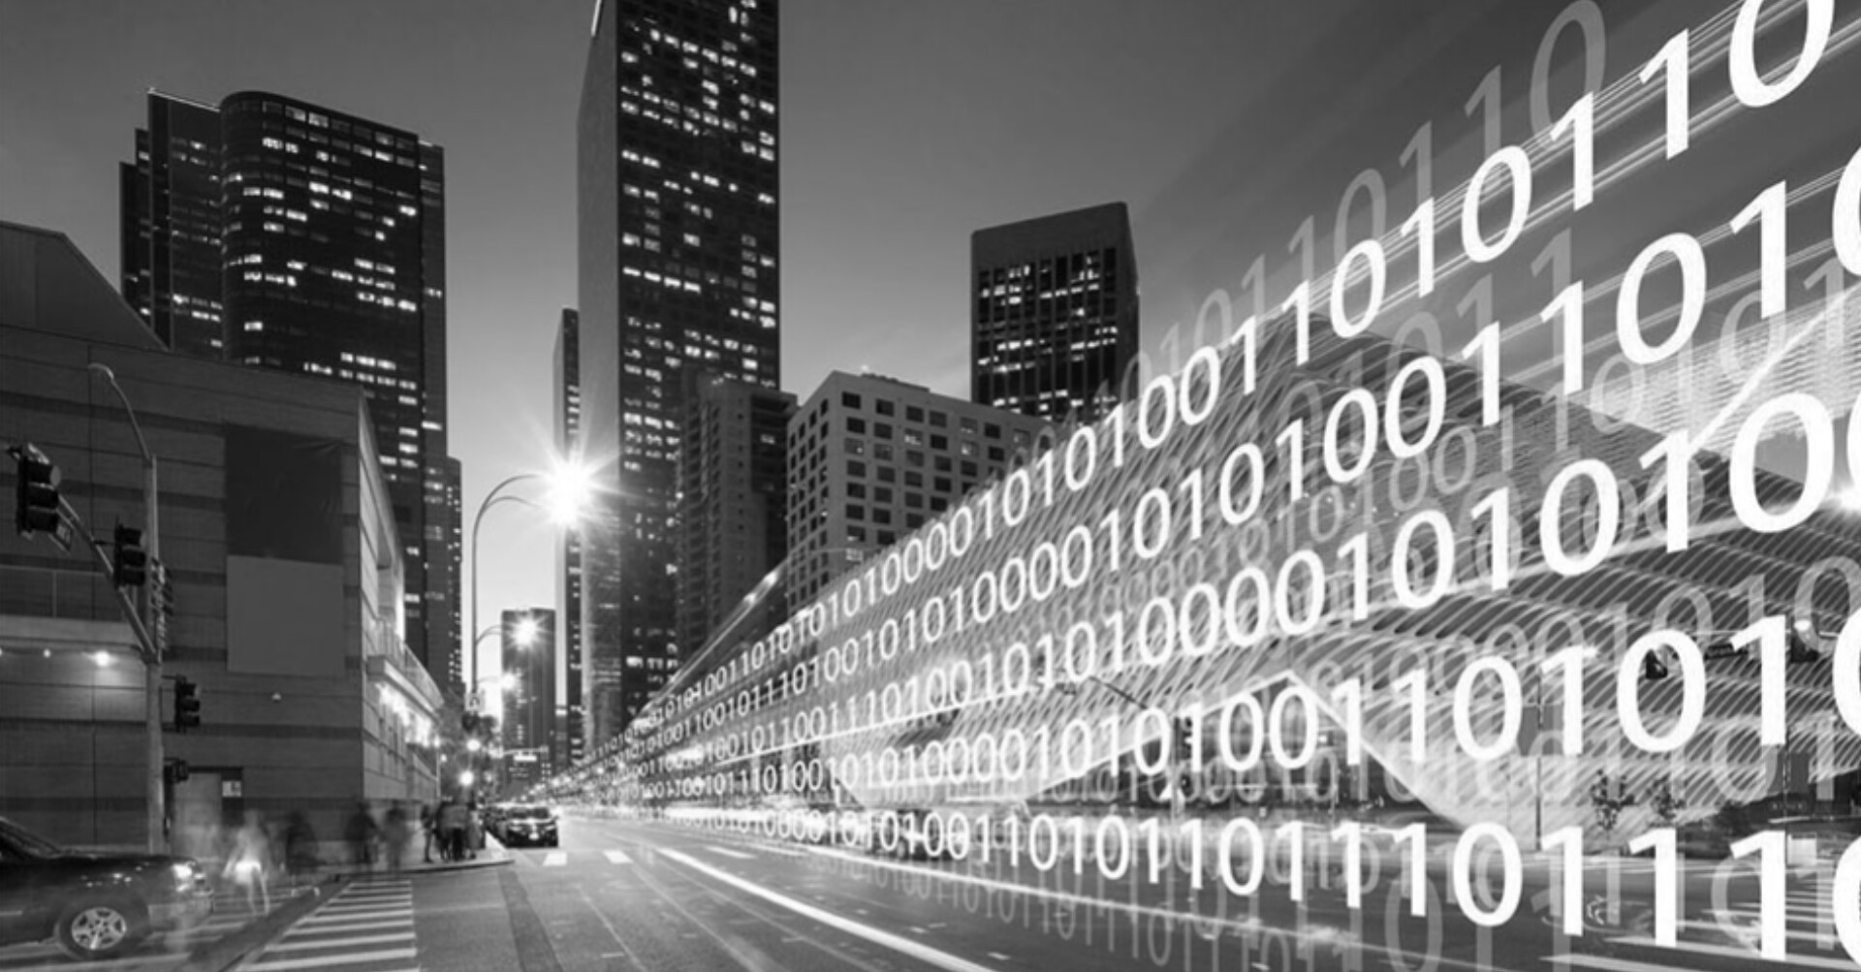It is also expected that around 88% of the new vehicles will involve IoT telematics by 2025. It ensures business Benefits like increased driver safety, better environmental conditions, real-time monitoring of the vehicles, and improved traveling experience.

How can smart technology be used to improve transport?

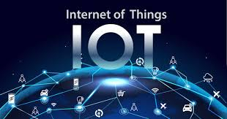Intelligent transportation systems enable local governments to manage traffic more efficiently through real-time monitoring and continuous data collection. These systems can estimate delay times, change speed limits, close off exits, and provide live CCTV footage of key intersections.

# What are the examples of IoT in public sector?

Enhance Public Safety

The most common example is a fire alarm. Thus, IoT helps in preventing crimes before they happen and respond to emergencies more quickly than humans

# Certainly! Here are brief notes outlining the integration approach for IoT sensors to send data to the real-time transit information platform:

1. **Sensor Deployment and Data Collection:**

- Strategically deploy IoT sensors (e.g., GPS, passenger counters) on public transportation vehicles.

- Sensors continuously collect relevant data such as location, passenger count, and vehicle status.

2. **Data Processing and Aggregation:**

- Sensors process collected data locally, aggregating it into structured packets.

- Data may be pre-processed onboard to reduce the volume of information transmitted.

3. **Communication Protocols:**

- Utilize efficient and lightweight communication protocols (e.g., MQTT, CoAP) suitable for IoT devices.

- Establish a reliable and secure connection between sensors and a centralized server.

4. **Edge Computing for Pre-processing:**

- Employ edge computing at the vehicle level to preprocess data before transmission.

- Edge devices can filter and aggregate data, minimizing the load on the central server.

5. **Real-Time Data Transmission:**

- Sensors transmit preprocessed or raw data securely to the centralized server over cellular networks, Wi-Fi, or other communication channels.

- Ensure near real-time data transmission for timely updates to the transit platform.

6. **API Integration:**

- Develop APIs to receive data from IoT sensors, defining the data format and endpoints for data submission.

- APIs should authenticate and authorize the incoming sensor data.

7. **Data Processing and Validation:**

- The centralized server receives sensor data and validates it for accuracy and completeness.

- Process the data for errors or anomalies and ensure it meets defined quality standards.

8. **Database Storage:**

- Store the validated sensor data in a dedicated database, organizing it for easy retrieval and analysis.

- Choose an appropriate database solution to handle the data volume efficiently.

9. **Real-Time Updates on the Platform:**

- Implement mechanisms to trigger real-time updates on the transit platform whenever new sensor data is received and processed.

- Display the information such as vehicle locations, passenger count, and arrival predictions to users.

10. **Scalability and Redundancy:**

- Design the integration architecture to be scalable, allowing for an increasing number of IoT sensors and expanding data volume.

- Include redundancy and failover mechanisms to ensure continuous data flow even during system disruptions.

By following this approach, IoT sensors on public transportation vehicles can reliably send data to the real-time transit information platform, enabling efficient and accurate updates for passengers and transit operators.

# Components for iot based public transportation optimization

1. 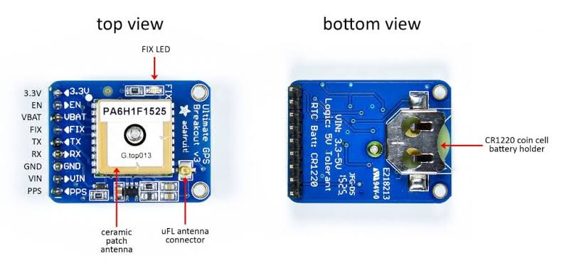gps sensor
2. Passanger counter sensor

